1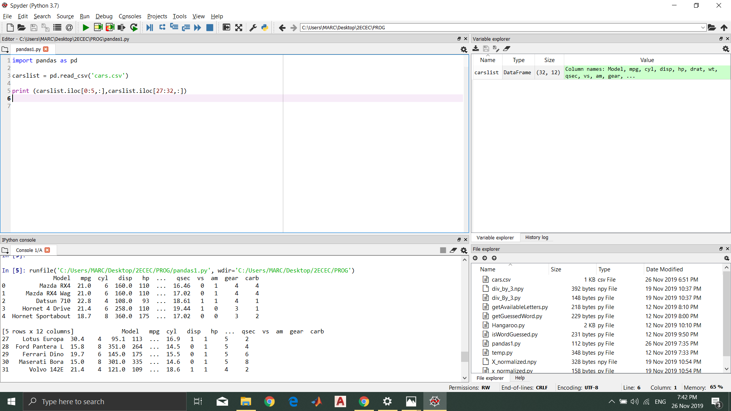

Model mpg cyl disp hp ... qsec vs am gear carb

0 Mazda RX4 21.0 6 160.0 110 ... 16.46 0 1 4 4

1 Mazda RX4 Wag 21.0 6 160.0 110 ... 17.02 0 1 4 4

2 Datsun 710 22.8 4 108.0 93 ... 18.61 1 1 4 1

3 Hornet 4 Drive 21.4 6 258.0 110 ... 19.44 1 0 3 1

4 Hornet Sportabout 18.7 8 360.0 175 ... 17.02 0 0 3 2

[5 rows x 12 columns]

Model mpg cyl disp hp ... qsec vs am gear carb

27 Lotus Europa 30.4 4 95.1 113 ... 16.9 1 1 5 2

28 Ford Pantera L 15.8 8 351.0 264 ... 14.5 0 1 5 4

29 Ferrari Dino 19.7 6 145.0 175 ... 15.5 0 1 5 6

30 Maserati Bora 15.0 8 301.0 335 ... 14.6 0 1 5 8

31 Volvo 142E 21.4 4 121.0 109 ... 18.6 1 1 4 2

[5 rows x 12 columns]

2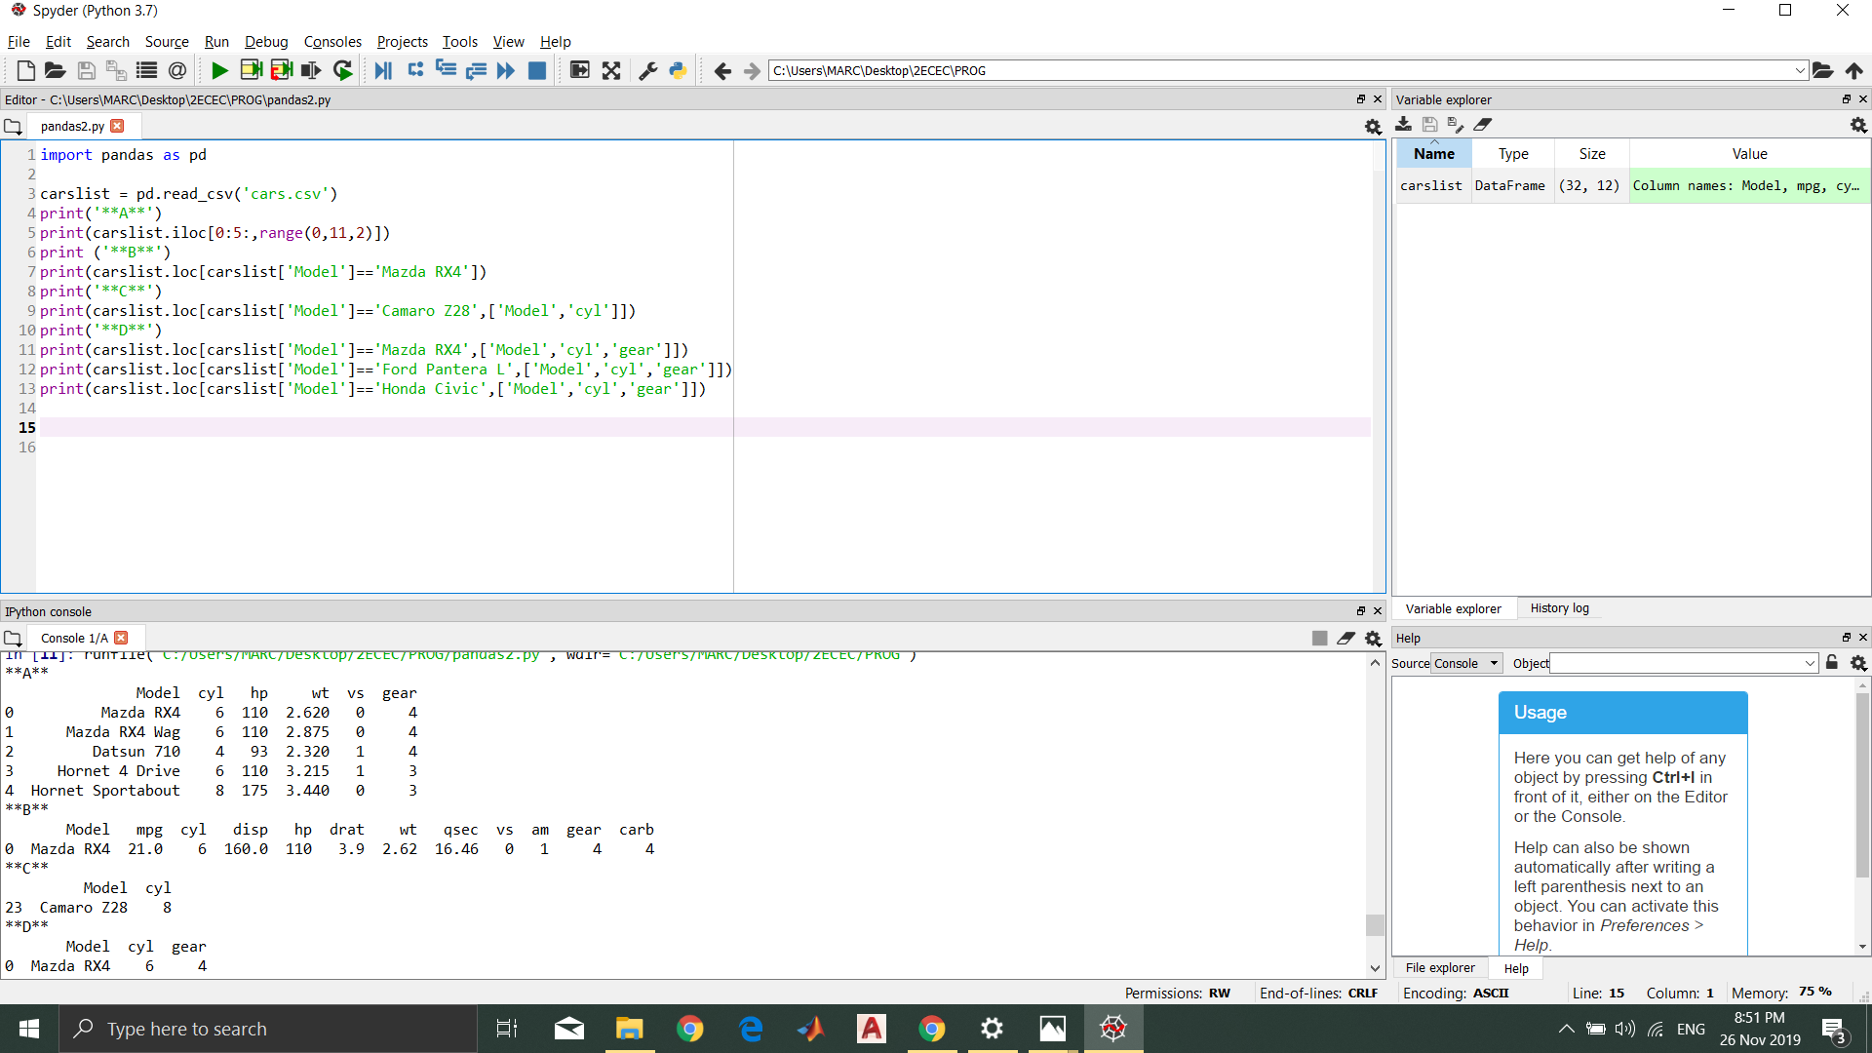

a.)

Model cyl hp wt vs gear

0 Mazda RX4 6 110 2.620 0 4

1 Mazda RX4 Wag 6 110 2.875 0 4

2 Datsun 710 4 93 2.320 1 4

3 Hornet 4 Drive 6 110 3.215 1 3

4 Hornet Sportabout 8 175 3.440 0 3

b.)

Model mpg cyl disp hp drat wt qsec vs am gear carb

0 Mazda RX4 21.0 6 160.0 110 3.9 2.62 16.46 0 1 4 4

c.)

Model cyl

23 Camaro Z28 8

d.)

Model cyl gear

0 Mazda RX4 6 4

Model cyl gear

28 Ford Pantera L 8 5

Model cyl gear

18 Honda Civic 4 4